- Introduction to WAN Technologies : Definition of WAN, Types of WAN Connections, WAN Devices: CSU/DSU, WAN Aggregators.
Tasks
1.Create a table comparing at least three types of WAN connections (such as leased line, DSL, and MPLS) with columns for speed, cost, and typical use cases.

WAN Connection Type | Typical Speed | Cost | Reliability | Security | Typical Use Cases
Leased Line | 10 Mbps – 10 Gbps+ | High | Very High | High | Corporate headquarters, data centers, mission-critical applications
DSL (Digital Subscriber Line) | 1 Mbps – 100 Mbps | Low | Moderate | Moderate | Homes, small businesses, internet access
MPLS (Multiprotocol Label Switching) | 1 Mbps – 10 Gbps+ | Medium–High | High | High | Connecting branch offices, VoIP, enterprise WANs
Fiber Optic | 100 Mbps – 100 Gbps+ | Medium–High | Very High | High | High-speed internet, cloud services, large organizations
Cable Broadband | 10 Mbps – 1 Gbps+ | Low–Medium | Moderate | Moderate | Residential users, small offices
Satellite WAN | 10 Mbps – 500 Mbps | High | Moderate | Moderate | Remote locations, rural areas, ships, oil rigs
4G/5G Cellular WAN | 10 Mbps – 10 Gbps | Medium | Moderate–High | Moderate | Mobile offices, backup WAN connections, IoT deployments

2.Draw a labeled diagram (on paper or using any drawing tool) showing how a CSU/DSU connects a router to a WAN service provider, and explain the role of each device in 2-3 sentences.
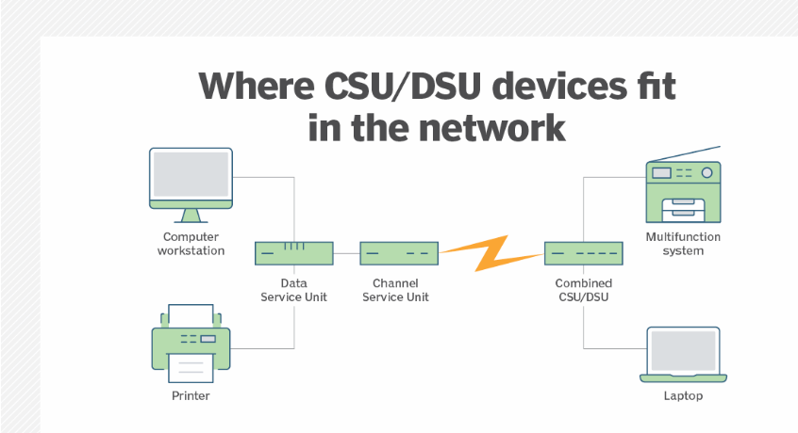
Device Roles and Explanations
- LAN (Local Area Network): Consists of end-user devices like computers and switches connected together within a localized area. It generates internal data traffic that needs to be sent out to external networks.
- Router: Examines the destination IP addresses of data packets coming from the LAN and determines the best path to send them. It connects the local network to the external WAN link by routing traffic through its serial interface to the CSU/DSU.
- CSU/DSU: Acts as a translator between the router and the telecom network. It converts the digital serial data from the router into a bipolar signaling format that can travel over the service provider's T1/E1 lines.
- WAN Service Provider: The telecommunications company's infrastructure that carries the digital signals over long distances. It connects geographically separated corporate branch offices or links the private business network directly to the public internet.

3.List three real-world examples of popular apps or services (like IRCTC, WhatsApp, or Zomato) that rely on WAN connections, and briefly describe how WAN enables their functionality
Popular apps like WhatsApp, Zomato, and IRCTC rely on Wide Area Networks (WANs) because they span vast geographical distances, seamlessly connecting mobile users and local servers across cities or globally.
Here are three real-world examples of how WAN connections enable their core functionality:
- WhatsApp (Instant Messaging & VoIP): Connects users globally by routing text messages, media, and voice calls over global WANs (the internet). This enables real-time, uninterrupted communication across different network providers and international borders.
- Zomato (Food Delivery): Relies on a combination of cellular and fiber-optic WANs to connect restaurants, delivery partners, and end-users in real-time. This dynamic connection is required for live order tracking, GPS navigation, and processing digital payments.
- IRCTC (Rail Ticketing & Reservation): Links millions of concurrent users to a centralized, highly secure database. WANs allow travelers to query seat availability, book tickets, and make payments from various devices nationwide, even during periods of heavy, localized web traffic.

4.Research online and find an image or datasheet of a physical WAN aggregator device used in enterprise networks. Paste the image or link, and write two key features of that device.
A physical WAN aggregator (like the Cisco Catalyst 8300 Series Edge Platforms) sits at the enterprise edge or data center, combining multiple transport links (MPLS, Internet, and 5G/LTE) into a single logical network.
Key Features:
- Intelligent Path Control: Automatically steers traffic across the best available WAN connection based on real-time performance metrics (latency, packet loss, and jitter) to ensure optimal application uptime.
- Integrated Security Services: Consolidates networking and cybersecurity, featuring built-in stateful firewalls, application-aware encryption (IPSec), and Zero-Trust network access.

